**A Greedy-based calculation method of RBS maximum allowable current**

Cheng Qian, Guangbin Hua, Binghui Xu, Quan Xia, Bo Sun, Yi Ren, Zili Wang

School of Reliability and Systems Engineering, Beihang University, Beijing, 100191, China

**Abstract**

Reconfigurable Battery Systems (RBSs) offer a promising alternative to traditional battery systems owing to their dynamical topologic structure for the optimization of battery cell charging and discharging strategies. During the operation of the RBS, the Maximum Allowable Current (MAC) is a critical indicator to guide the refactoring control of the system in terms of safety and reliability. This paper firstly proposes a method to calculate the MAC of the RBS based on its structure. In the developed method, the directed graph is utilized to model the structure of RBS, and a greedy strategy is proposed to find the potential connections of batteries that enable the maximum current. Finally, an equivalent circuit model of battery cell is employed to calculate the current value of the selected circuit. The effectiveness of this method is validated on RBS structures of various sizes and configurations. The results also demonstrate that the ratio of the output current to the maximum battery current can better reflect the structural performance of RBS than the output current value.

**Keywords**

Reconfigurable battery system, maximum allowable current, greedy algorithm,

**I. Introduction**

Battery Energy Storage Systems (BESSs) are widely used to store and supply high-quality electrical energy in various applications, such as electric vehicles and wind power plants [1, 2, 3, 4]. Typically, a BESS consists of numerous battery cells that are interconnected by series-parallel circuitry to provide the required charged capacity and output voltage. For the traditional BESS, the connections between batteries are fixed and the performance of system is limited by the worst cell, as the result of the cask effect. Furthermore, reliability and even safety issues will also be aroused since the failed battery cannot be promptly isolated to exacerbate the degradation of the other batteries during the operational process [5, 6]. Undoubtedly these issues hinder the practical application of traditional BESSs.

Reconfigurable Battery System (RBS), which can dynamically switch to arbitrary circuit configurations as required, is expected to solve the above problems [9]. Unlike traditional BESSs with a fixed battery connection, RBS use additional switches to change the series/parallel connection mode between batteries, which greatly improves the flexibility, safety and reliability of the system. Fig.1 shows two popular typologies of the RBSs developed by Lawson [7] and Visairo [8] respectively. Taking the RBS shown in Fig.1 (b) as example, the batteries are connected not only in series when the switches $S_{1}$, $S_{5}$, $S_{6}$, $S_{7}$, $S_{8}$, $S_{9}$, and $S_{13}$ are closed, but also in parallel when $S_{1}$, $S_{2}$, $S_{3}$, $S_{4}$, $S_{5}$, $S_{9}$, $S_{10}$, $S_{11}$, $S_{12}$ and $S_{13}$ are closed. Furthermore, when an unhealthy battery, for instance the orange one in Fig.1 (a), exists in the RBS, it can be isolated by closing its three adjacent switches (i.e. S5, S7 and S8) and opening the switch below that battery (i.e. S6) to ensure the system still remains a reliable working mode.



**Fig. 1 The RBS structure proposed by (a): Lawson [7], (b): Visairo [8] and (c): synthesized from (a) and (b).**

The complex connection structure between batteries and switches enables the flexibility of the RBS, but also brings the challenges in design and control cost. The Maximum Allowable Current (MAC) of the RBS system is defined as the maximum current that is allowed for each individual battery of the system, and is a critical indictor to be evaluate the RBS output current to the electronic appliances. It helps the designers to assess whether the RBS meets the output current requirements, and contributes to the formulation of appropriate and safe management strategies for the battery management system (BMS). Despite its importance, there is currently no method available to evaluate MAC for RBSs. Therefore, the purpose of this paper is to propose a universal and effective method for calculating the MAC of the RBS. To achieve this, models with RBS connection relationships and component status information are established. Then, a greedy algorithm is employed to search the available circuit of the RBS for reaching the MAC. With the developed method, MAC of RBSs with different structures or different number of batteries can be calculated effectively.

The remainder of this paper is structured as follows: Section II presents the framework and details of the proposed XX model. In Section III, taking a specific structure as an example, the application of the method is demonstrated, and the effectiveness of the method on RBS with different structures and sizes is verified. Finally, the concluding remarks are drawn in Section IV.

**II. Methodology**

The overall MAC modelling process from an RBS structure is shown in Fig. 2, which can be divided into four main steps. In the first place, the actual RBS structure is converted to a graph model, in which the shortest path of … is obtained. Then, an equivalent circuit model is established based on the graph model for solving the voltage and current in the circuit. Finally, by greedily searching for the combination of the shortest path, the MAC is calculated in the corresponding equivalent circuit model.



**Fig. 2 Flowchart of the MAC modeling process.**

**A. Graph model and circuit model**

As demonstrated in Fig. 1, a typical RBS is made up of a number of battery cells and switches in a dynamically adjustable connection. To establish a processable circuit, these components are transformed into ideal elements under reasonable assumptions. The resulting circuit structure is then described in matrix form, and the related equations are provided.

The normal equivalent circuit for a battery consists of a voltage source in series with a resistor, and a capacitor in parallel with another resistor to simulate the polarization in batteries. When calculating the MAC that can be delivered steadily from the RBS, only the steady-state behavior of the battery is considered, where the transient behavior is ignored. In this way, battery $i$ in the RBS is modeled by the series connection in between a constant voltage source $u_{b,i}$ and a resistor $r_{b,i}$. And a binary variable $x_{j}$ is used to represent the state of switch $j$, which are 0 for ON and 1 for OFF, respectively. To simplify the calculation, a closed switch is considered as a resistor with a very small resistance value $r_{s}$.

For a given RBS architecture, a directed graph model $G(V,E)$ for the RBS is constructed in such a way that:

* Nodes: the vertex set $V=\{v_{1},v_{2},…,v_{n}\}$ represents the nodes connecting batteries and/or switches, where $v_{1}$ and $v_{n}$ represent the anode and cathode of the RBS respectively, and the …;
* Edges: the directed edge set $E$ represents the output circuit, $N_{b}$ batteries and $N_{s}$ switches, corresponding set $E_{O}$, $E_{b}$ and $E_{s}$. The external electrical equipment in the output circuit is treated as one directed edge $v_{n}→v_{1}$. The direction of the edge indicates that the battery is set to be from the anode to the cathode. For the edges representing switches, their directions are marked from the low node to the high node. A negative voltage drop or current indicates the direction of the corresponding edge should be opposite to its initially settings.

Based on the above directed graph which has $N$ nodes and $1+N_{b}+N_{s}$ directed edges (1 refers to the output circuit), its incidence matrix $A_{N×(1+N_{b}+N_{s})}$ is defined as Eq. (1).

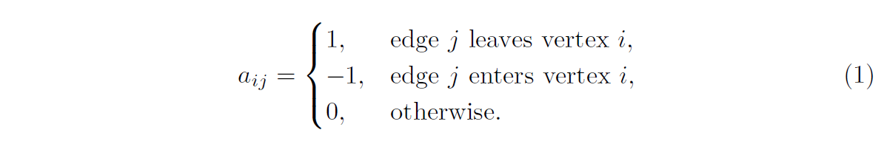

Since each column of $A$ sums to zero, the last line is deleted and the reduced incidence matrix $A_{(N-1)×(1+N_{b}+N_{s})}$ are used in the following calculation. By splitting $E$ into $\{E_{o}, E_{b}, E_{s}\}$, $A$ is rewritten as Eq. (2).



$1+N_{b}+N_{s}$ edges' currents $I_{(1+N_{b}+N_{s})×1}$ and voltages $U_{(1+N_{b}+N_{s})×1}$, and $N-1$ nodes' voltages $U_{n,(N-1)×1}$ have following relationships from Kirchhoff’s law.

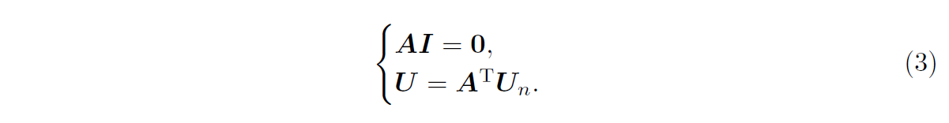

These directed edges are treated as generalized branches and expressed in matrix form as follows



where $I$ and $U$ are the column vectors about $1+N_{b}+N_{s}$ edges' current and voltage, respectively; $U_{s}$ and $I_{s}$ denote the source voltage and source current of the generalized branches, respectively; $Y$ is the admittance matrix of the circuit, and $X$ is the state matrix defined as

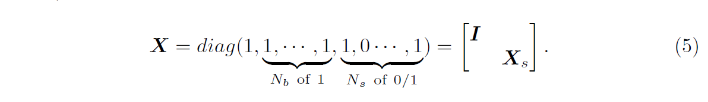

In addition to the equivalent circuit assumptions, we also assume that all batteries have the same internal resistance value $r_{b}$ and supply the same electric potential $u_{s}$ to simplify the model. Then the output current $I_{o}$ and each battery's current $I_{b}$ can be given by solving the simultaneous Eq. (3) and Eq. (4) eventually. Let

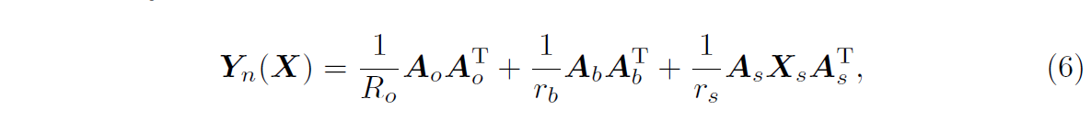

where $R_{O}$ is the equivalent resistance of the external circuit. Then, if $Y_{n}$ is an invertible matrix, the current of system and battery can be obtained as follows

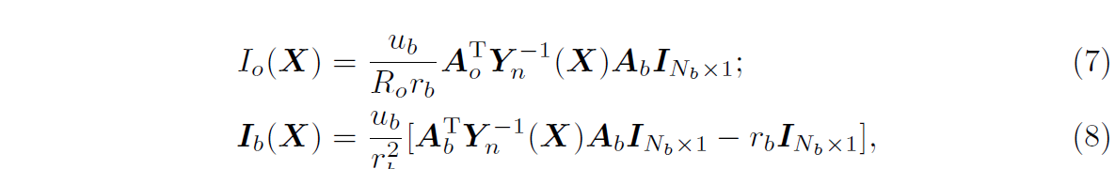

Where $I_{N_{b}×1}$ is a column vector with all terms equal to 1.

In this study, the ratio of $I_{o}$ and ${max⁡(I}_{b})$ is used to characterize the maximum allowable current for a given RBS architecture, denoted as $η$. The discussion in the next section will show that the $η$ reflects the ability of the RBS architecture itself to deliver current, regardless of the battery cells used by the RBS. Finally the problem in RBS can be formulated as

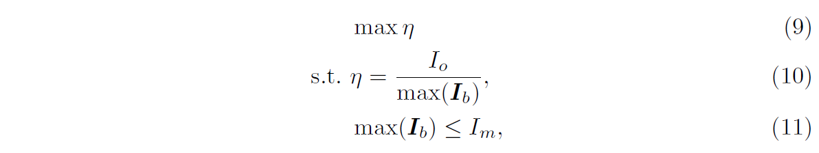

where $I_{m}$ is the maximum allowable current of the battery; $I_{o}$ and $I_{m}$ can be calculated by Eq. (7) and (8). However, it is difficult to solve Eq. (9) directly because of the presence of matrix $Y_{n}^{-1}$. A greedy algorithm is proposed to solve this problem in the next subsection.

**B. Greedy solution**

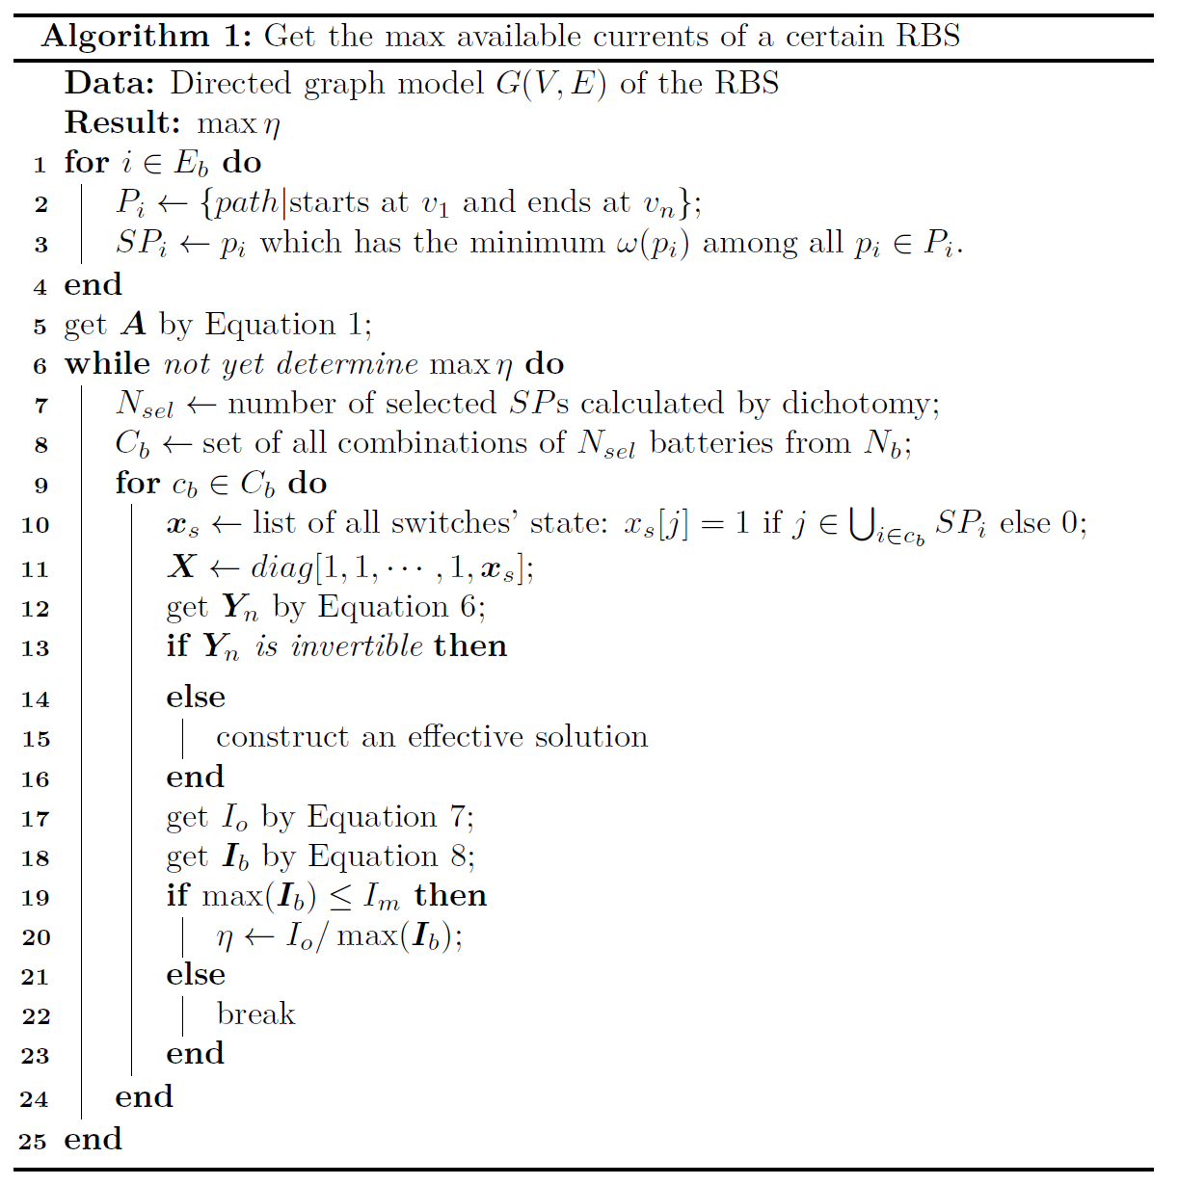

First, the shortest path ($SP_{i}$) of battery $i$ is calculated. When battery $i$ is connected to the anode $v_{1}$ and the cathode $v_{n}$ of the RBS by the path $p$ in the graph model, the length $ω$ of $p$ is defined by the following equation:

where $N_{s}$ is the total number of switches in the system; $n_{b}(p)$ and $n_{s}(p)$ are number of batteries and switches in the path $p$ respectively. $SP_{i}$ is defined as the path with the minimum $ω$ for battery $i$. According to the definition, $SP_{i}$ gives the simplest strategy by which the control of battery $i$ is achieved with a minimum of switches while minimizing the influence of other batteries. From the perspective of series/parallel, the more batteries are connected into circuit via their SPs, the more batteries are connected in parallel. Since batteries can provide more total output current when connected in parallel than in series, the algorithm greedily selects as many cells as possible to be connected into to the overall circuit via their SPs to obtain the MAC. The dichotomy method is also performed to faster find the right number of SPs. The pseudo-code of the algorithm is shown in Algorithm 1.

**III. Case study**

~~This section verifies the effectiveness of the developed method on several structures. Firstly, the detailed modeling and solving process of a specific RBS structure (proposed by [8]) with four battery cells is given. Then, the effectiveness of the method is verified on RBSs with different structures and sizes. This section also explains the advantages of using $η$ to characterize MAC.~~

**A. Determination of …**

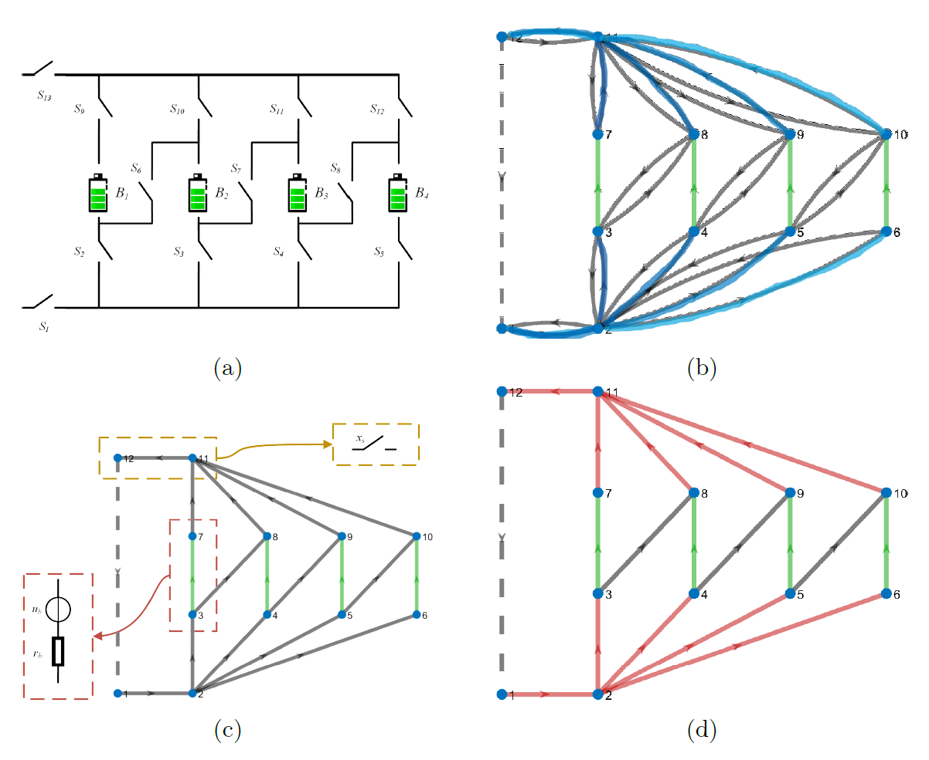

**Fig. 3 Illustration of models build in MAC calculation process. (a): physical model of RBS proposed by Visairo [8], (b): graph model of the RBS, (c): equivalent circuit model of the RBS, (d): the shortest paths find by the greedy strategy.**

The reconfigurable architecture proposed by Visairo et al. [8] is shown in Fig.3 (a). In this architecture, each cell is controlled by about 3 switches on average. Excepted for two switches ( $S_{1}$ and $S_{13}$ in Fig.3 (a)) which is used to control the total circuit, the vertical switches (e.g. $S_{2}$ and $S_{9}$) allow the batteries to be directly connected to the main circuit, and the switches in the diagonal direction ( for example) can connect the batteries in series. Thus, it can dynamically change the output voltage and current as needed. The architecture in Fig.3 (a) only has 4 batteries, but in practice it can add new branches containing batteries and switches to deal with large-scale batteries [10].

The graph in Fig.3 (b) provides the directed graph model of the RBS of Fig.3 (a), to show the connection relationship between the battery and switch in the circuit. In this model, Vertex 1 and 12 represent the anode and cathode of the RBS, respectively; the remaining vertices represent the connection nodes between the batteries and switches. Battery 1, 2, 3, and 4 are represented by green directed edges in the graph, while switches are represented by gray directed edges with opposite directions. The external electrical appliance is considered as a directed edge from node 12 to node 1. In the graph model, the directionality of the edges is strictly specified to ensure that there is no reverse flow of current in the battery and external electrical appliance.

According to Eq. (12), the weight *N*s of the edge corresponding to the battery is the total number of switches, which equals to 13; the weight of the edge corresponding to the switch is 1.

These weight parameters are set in twofold reasons. On the one hand, they avoid the simultaneous occurrence of multiple batteries in a single SP, to reduce the influence from different batteries. On the other hand, they minimize the number of switches on the path, to allow only a few switches (i.e., the switches on the SP) to be closed to ~~connect the batteries of the circuit~~. By using the depth-first search algorithm, the SP of battery 1 can be calculated as the node list [1, 2, 3, 7, 11, 12], and the SPs of the other batteries are shown in Fig.3 (b).

The equivalent circuit model of the RBS in Fig.3 (a) is shown in Fig.3 (c). In this model, the batteries and switches are treated as branches, where the battery is regarded as a branch consisting of a voltage source $u_{b}$ in series with a resistor $r_{b}$, and the switch is regarded as a branch controlled by a state variable $x_{s}$ to short or open the circuit. The branches are represented as direction edges, whose direction is from the node with the smaller number to the larger. When the computed current or voltage value is negative, it indicates that the direction of the battery or potential difference is opposite to the preset direction. Based on the node-edge relationship given in Fig.3 (c), the incidence matrix $A$: can be obtained according to Eq. (1):

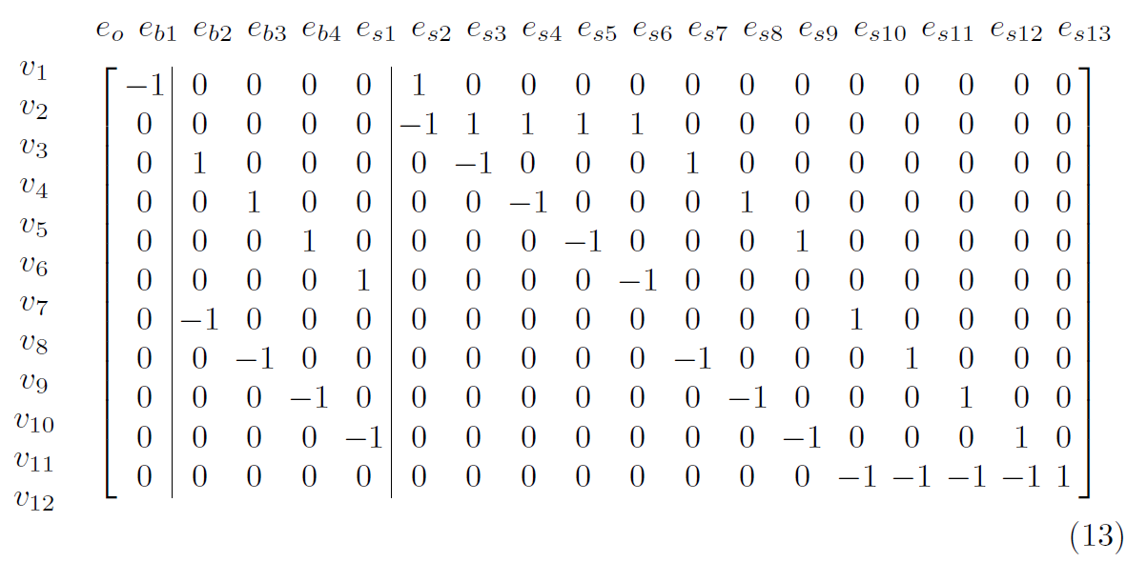

where the rows correspond to vertexes in the graph model, and the first column, second to fourth columns, and last ten columns correspond to external electrical equipment, 4 batteries, and 13 switches, respectively. According to the above classification of the columns, the matrix $A$ can be divided into $A_{o}$, $A_{b}$, and $A_{s}$.

The state matrix $X$ is determined by the switches' state, that is, the specific configuration of the RBS. For example, when switch $S_{1}$, $S_{2}$, $S_{3}$, $S_{4}$, $S_{5}$, $S_{9}$, $S_{10}$, $S_{11}$, $S_{12}$ and $S_{13}$ are closed, and switch $S_{6}$, $S_{7}$ and $S_{8}$ are open, battery $B_{1}$, $B_{2}$, $B_{3}$ and $B_{4}$ are then connected in parallel to supply the external circuit, the state matrix $X$ is given by

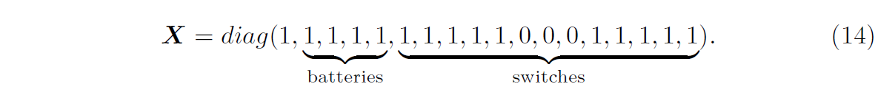

When using the algorithm to solve the MAC, one may encounter the situation where the matrix $Y_{n}$ is not full rank, and its inverse matrix cannot be directly obtained. This is because so many switches are open that some branches with voltage sources are independent of the main circuit and form new circuits. These circuits have infinite possible values for potential difference between them, since they are not connected to each other. But the potential of the main circuit, which connects from node 1 to node 12 and completely determines the output, is certain and unique. Therefore, the non-invertibility of $Y_{n}$ will not affect the final solution. Here, one can choose the solution where the potential at the node with the smallest number in the independent branch is 0.

**Table 1. Detailed results of the proposed method for the RBS shown in Fig. 1(b).**

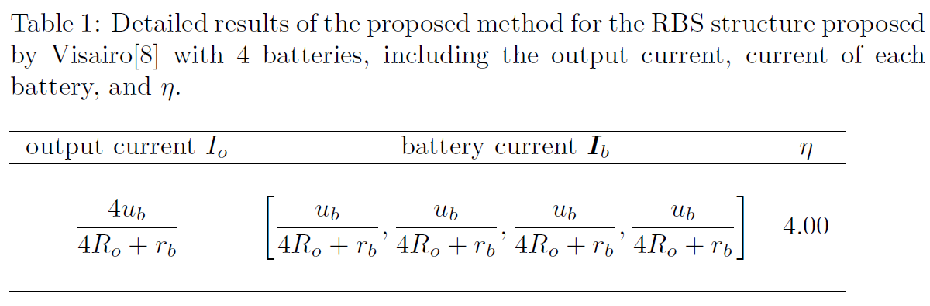

By using Eq. 10, the final result of $η$ for the RBS in Fig.3 (a) is 4. The corresponding currents of output and each battery are shown in Tab. 1. The corresponding switch control strategy is: $S_{1}$, $S_{2}$, $S_{3}$, $S_{4}$, $S_{5}$, $S_{9}$, $S_{10}$, $S_{11}$, $S_{12}$ and $S_{13}$ are closed (highlighted in red in Fig.3 (d), and $S_{6}$, $S_{7}$, $S_{8}$ are open. In this case, when all batteries are connected to the main circuit through the switches in the vertical direction in Fig.3 (a) and the batteries are connected in parallel, the output current is maximum, which is the sum of the currents of the four batteries.

From the specific results of the output current $I_{o}$ and battery currents $I_{b}$, both are related to the battery voltage $u_{b}$, internal resistance $r_{b}$, and external circuit resistance $R_{o}$. This means that even for the same structure, the output current will change when the external circuit or the battery specifications change. By dividing the output current by the sum of the battery currents, the obtained $η$ does not include items affected by external circuit and batteries. This characteristic is guaranteed by the linear nature of the RBS circuit.

**B. MAC calculation for RBS with different structures and sizes**

To further demonstrate the effectiveness of the models and algorithm, RBSs with different structures and sizes are considered. On the one hand, the modeling and solving of the three battery structures in Fig.1 are carried out, where the structure in Fig.1(a) is proposed by Lawson [7] and the structure in Fig.1(b) is proposed by Visairo [8]. The structure in Fig.1(c) is a combination of the two. All three structures have 4 battery cells. On the other hand, the modeling and solving of the battery structures proposed by Visairo [8] with different numbers of battery cells (2, 4, and 6 cells) are also carried out.

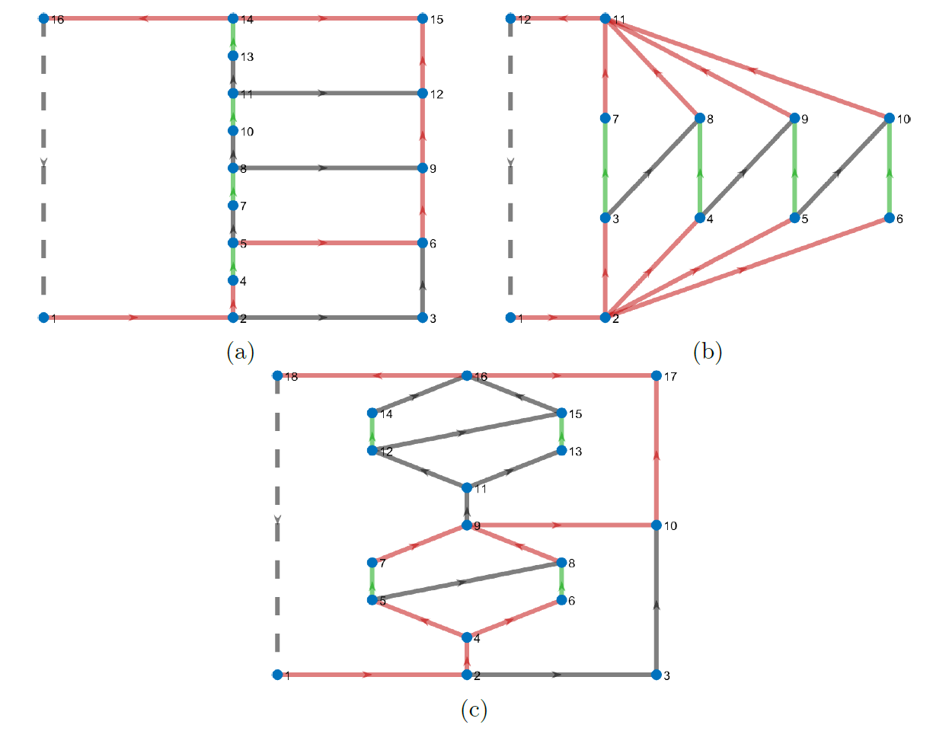

**Fig. 4 The circuit of RBS find by the developed greedy strategy which enables the MAC for RBS with structure shown in Fig. 1 respectively.**

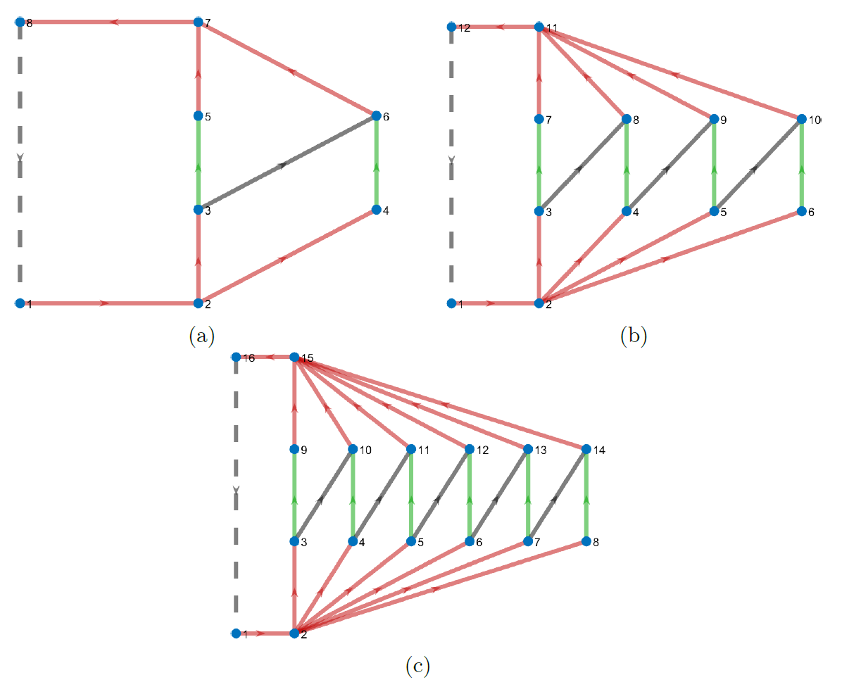

**Fig. 5 The circuit of RBS find by the developed greedy strategy which enables the MAC for RBS on structure developed by Visairo [8] with (a) 2, (b) 4 and (c) 6 batteries.**

The greedy algorithm provided accurate estimates of the structure MAC and generated safe and effective switch control strategies, as indicated by the results shown in Fig.4 and Fig.5, where the highlighted red switches denote the closed positions. Furthermore, the results about currents in Tab.2 and Tab.3 show that the output currents are influenced by the external circuit resistance, battery potential, and internal resistance, but are linearly related to the battery currents, consistent with the conclusion about $η$ in the previous subsection.

**TABLE 2. Detailed results of proposed method for RBS shown in Fig. (1).**

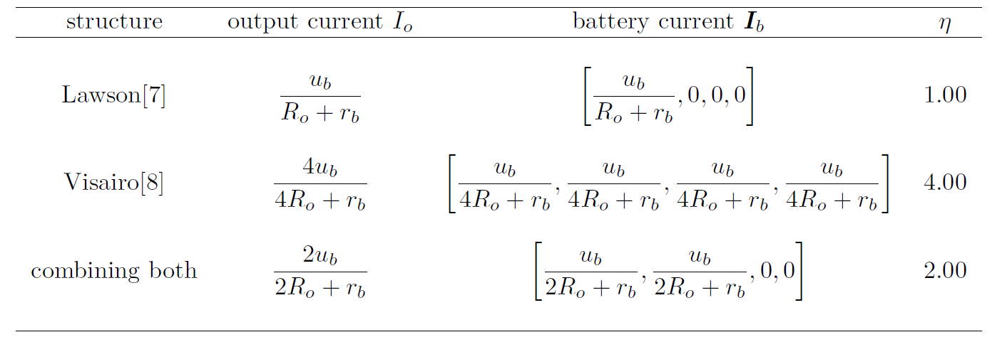

**TABLE 3 Detailed results of proposed method for RBS on structure developed by Visairo [8] with different battery size.**

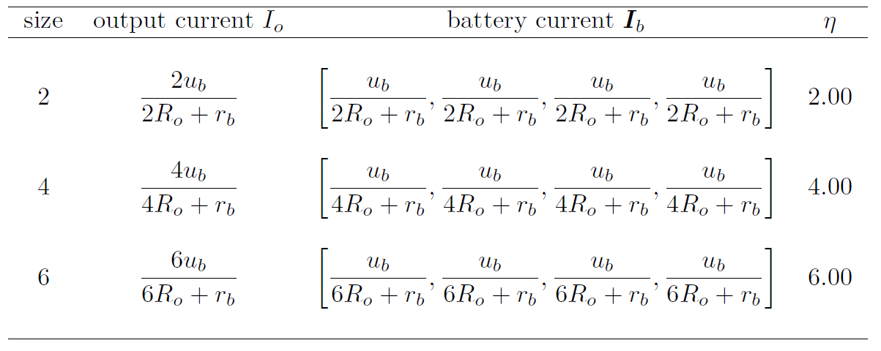

**IV. Conclusion**

This paper firstly proposes a method to calculation the MAC of RBS according to its architecture. To find the circuit in RBS that enable the MAC, a greedy strategy incorporate with the graph model is developed to. Then, the circuit model is employed to calculate the corresponding current value of the circuit found. The effectiveness of proposed method is tested on RBSs of varying structures and sizes. This work presents an effective approach to evaluate the MAC of RBS, which is essential for design and management of the RBS. Future research could focus on developing new performance indicators for evaluating RBS performance using the currents and voltages obtained by this method, as well as modifying the equivalent model of the battery to enable more accurate simulations of RBS, including transient analysis.

**Reference**

1. L. M. S. de Siqueira and W. Peng, “Control strategy to smooth wind power output using battery energy storage system: A review,” *Journal of Energy* *Storage*, vol. 35, p. 102252, Mar. 2021.
2. R. Karandeh, T. Lawanson, and V. Cecchi, “A Two-Stage Algorithm for Optimal Scheduling of Battery Energy Storage Systems for Peak-Shaving,” in *2019 North American Power Symposium (NAPS)*, pp. 1–6, Oct. 2019.
3. Y. Yang, S. Bremner, C. Menictas, and M. Kay, “Battery energy storage system size determination in renewable energy systems: A review,” *Renewable* *and Sustainable Energy Reviews*, vol. 91, pp. 109–125, Aug. 2018.
4. J. Cho, S. Jeong, and Y. Kim, “Commercial and research battery technologies for electrical energy storage applications,” *Progress in Energy and* *Combustion Science*, vol. 48, pp. 84–101, June 2015.
5. N. Yang, X. Zhang, B. Shang, and G. Li, “Unbalanced discharging and aging due to temperature differences among the cells in a lithium-ion battery pack with parallel combination,” *Journal of Power Sources*, vol. 306, pp. 733–741, Feb. 2016.
6. F. Feng, X. Hu, L. Hu, F. Hu, Y. Li, and L. Zhang, “Propagation mechanisms and diagnosis of parameter inconsistency within Li-Ion battery packs,” *Renewable and Sustainable Energy Reviews*, vol. 112, pp. 102–113, Sept. 2019.
7. B. Lawson, “A Software Configurable Battery,” *EVS26 International Battery, Hybrid and Fuel Cell Electric Vehicle Symposium*, 2012.
8. H. Visairo and P. Kumar, “A reconfigurable battery pack for improving power conversion efficiency in portable devices,” *2008 7th International* *Caribbean Conference on Devices, Circuits and Systems*, pp. 1–6, Apr. 2008.
9. W. Han, T. Wik, A. Kersten, G. Dong, and C. Zou, “Next-Generation Battery Management Systems: Dynamic Reconfiguration,” *IEEE Industrial* *Electronics Magazine*, vol. 14, pp. 20–31, Dec. 2020.
10. H. Kim and K. G. Shin, “Dependable, efficient, scalable architecture for management of large-scale batteries,” in *Proceedings of the 1st ACM/IEEE* *International Conference on Cyber-Physical Systems*, ICCPS ’10, (New York, NY, USA), pp. 178–187, Association for Computing Machinery, Apr. 2010.